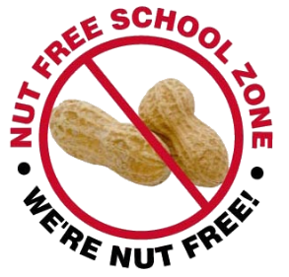

13th September 2019

Dear Parents/Carers,

There are children within school who have a variety of additional needs and I am writing to you to remind you that we are a nut-free school.

People who suffer from nut allergies can develop a severe, potentially life-threatening allergic reaction.

If someone has a nut allergy it is not just eating nuts that can cause a severe reaction, just being touched on the skin or smelling the breath of someone who has had nuts or a product containing nuts can trigger anaphylactic shock (which can cause breathing and swallowing difficulties).

First aid staff in the school are trained to use the Epi-pens (an injection of adrenalin) which is required immediately if this happens. We cannot have nuts in school in any form. So please can we ask that you have no nut products in the lunch boxes or brought into the school as treats.

For example:
Peanut butter sandwiches
Chocolate spreads
Cereal bars
Granola bars Cakes that contain nuts
Biscuits / Cookies that contain nuts (including peanut butter)
Cakes

This list is not exhaustive, so please check the packaging of products closely. We appreciate that this is an additional thing to check but we know that you recognise the importance of it.

We do have to insist that we are a nut-free school. I know if this was your child you would expect that we all help, especially as it is a life-threatening condition.

If you have any questions, please do not hesitate to speak to a member of staff.

Yours sincerely,

Mrs Franklin
Headteacher

